May 3 draft
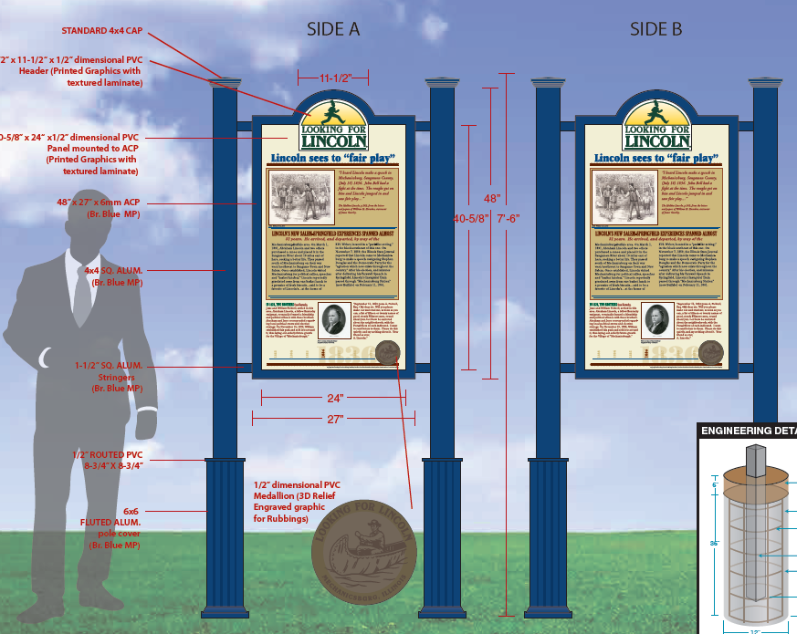

Proposing a Looking for Lincoln sign
to be installed at Barry Baptist Church

Sign Title: Lincoln, New Philadelphia, and Barry

$5,500 including installation. Details on next pages. NPA to supply images and text within LfL’s layout specifications and LfL does text review, design, sign fabrication and installation.
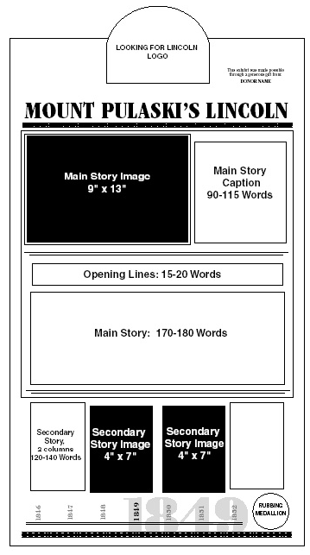
  - Side 1 (layout option A; C just separates the two bottom pix, in case that’s better)
Images (we have rights to all images and they are all excellent dots per inch):
Portrait of Lincoln by Calvin, with bill text inset
Frank McWorter bust
Lucy McWorter photo
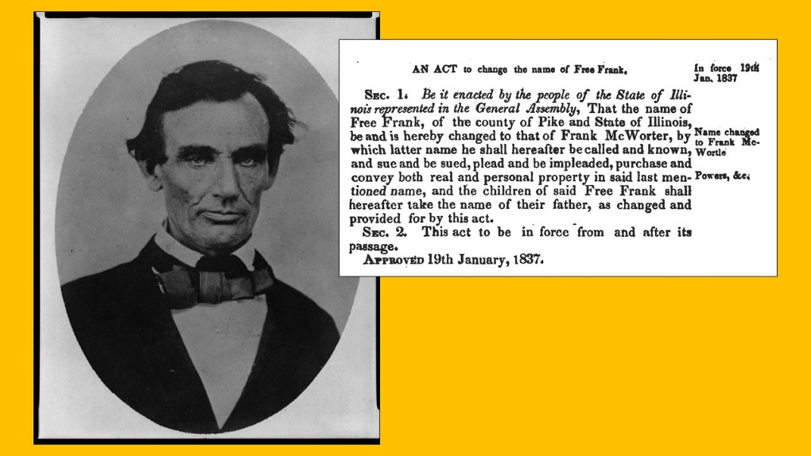
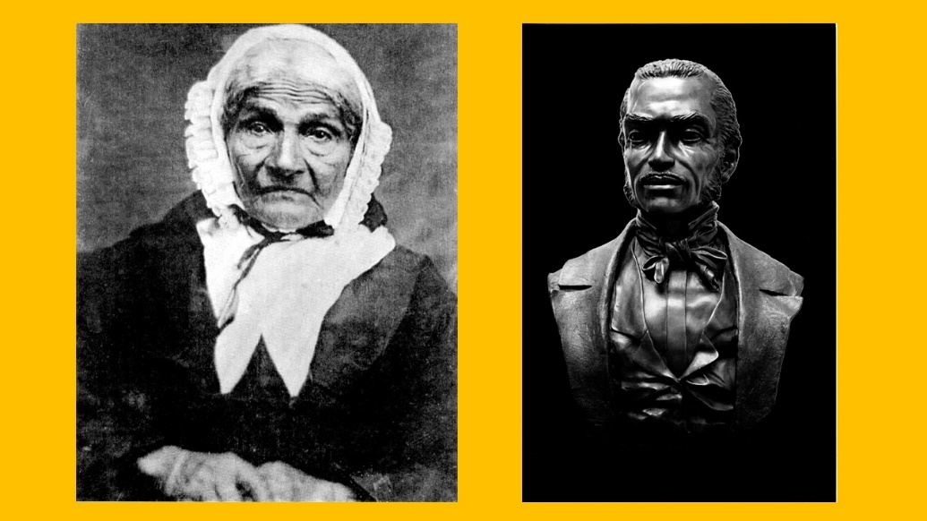
Main story caption: By 1837 Lincoln had been an Illinois state legislator for three years. Free Frank had just founded New Philadelphia, four miles east of here. He was selling town lots to help purchase family members out of slavery. Especially with all his business activity, Frank was determined to gain legal rights to protect himself. Illinois’ Black Codes, in effect from 1819 to 1865, denied black people these rights. So Frank got a name law drafted for himself (inset). It was introduced by Colonel William Ross, then Senator from Pike County. The Illinois General Assembly considered it on January 19, 1837. State Representative Abraham Lincoln was there that day with his vote. The McWorter Law passed! (115 words; specs say 90-115)
Opening lines: State Representative Abraham Lincoln was there when the Illinois Assembly passed the McWorter Act, January 19, 1837 (17 words; specs say 15-20)
Main story: Frank McWorter and his wife Lucy began their freedom journey with Frank’s purchase of Lucy—and her unborn child—in Kentucky in 1819. In 1831 they were the first settlers in Pike County’s Hadley Township. In 1836 they founded New Philadelphia—New City of Brotherly Love. In 1837 Frank won his legal rights in the Illinois General Assembly, with State Representative Abraham Lincoln present and accounted for.
Devotion and determination ran high in Frank and Lucy’s family. Enslaved McWorters in Kentucky named their children after free McWorters in Illinois. By the 1850s they had purchased 16 family members. Frank, his daughter Sarah, and others took their turns at the dangerous trip back to Kentucky to get family members.
New Philadelphians were both African American and European American. They sought freedom in seven ways. They bought their relatives. They ran. They founded an abolitionist town. They helped others run. They fought in the Civil War. And they lived free, on their own land, with guns, just 20 miles from slavery in Missouri. (171 words; specs say 170-180)
Secondary story: Frank, Lucy, and one son Commodore were members of Barry Baptist Church, as were Calvin and wife Nancy. Calvin Jackson “learned the art of photography in 1854” according to his obituary and took the above photo of Abraham Lincoln on October 1, 1858 in nearby Pittsfield. Besides sitting for this iconic image, Lincoln visited friends and enjoyed cider and gingerbread and gave a rousing speech on slavery, or, as he put it, on “the standard of free government that ‘all men are created equal.’”
Calvin Jackson maintained a “picture gallery” in Barry as well as opening a book and music store. He most likely took Lucy’s photo here. No photo of Frank has yet been identified. Descendant Shirley McWorter Moss sculpted his bust, studying living descendants and family photos and, in her words, “adding and subtracting.” (136 words; specs say 120-140 words)
Rubbing: The bust of Frank McWorter, as the primary link here to Lincoln. Text around edge of rubbing same as sign title.

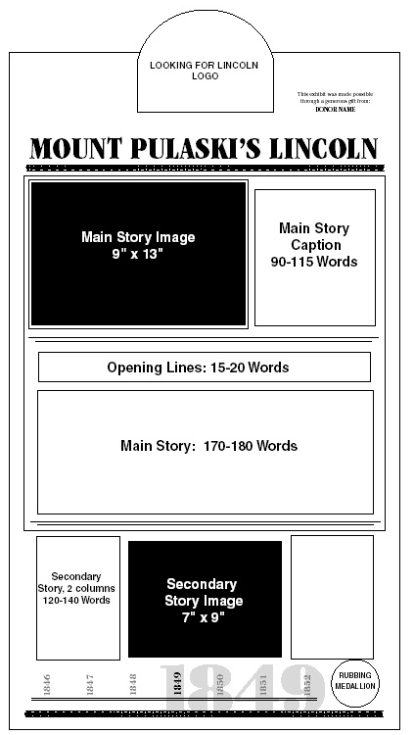
  - Side 2 (layout option B)
Images:
Church minutes text with cover
Barry Baptist Church engraving
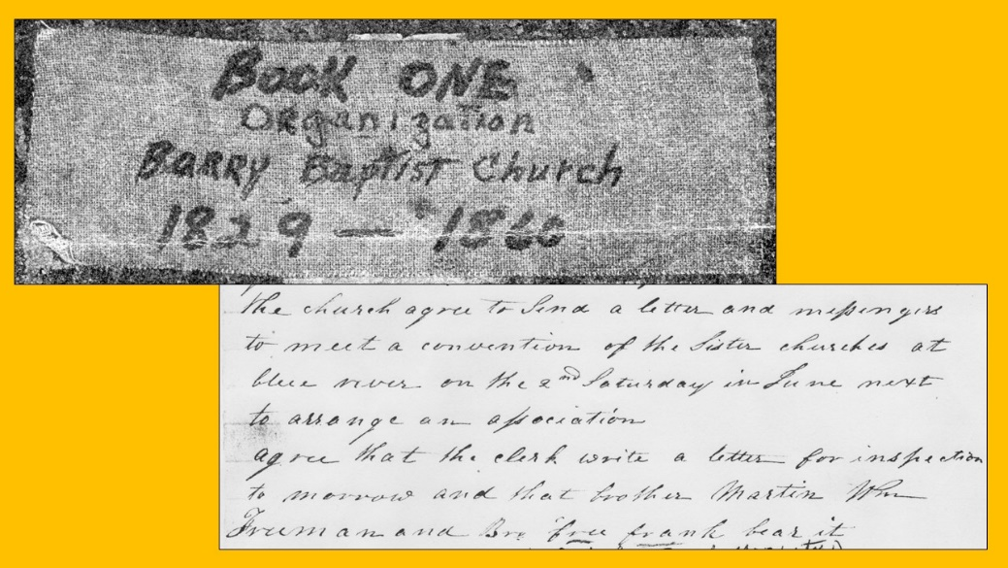
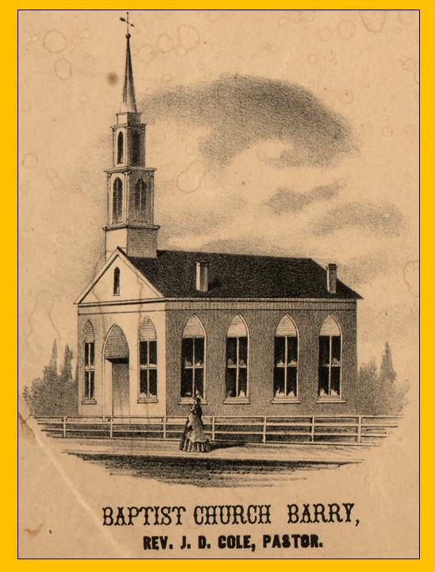
Main story caption: Barry Baptist Church minutes for May 4, 1833 record two decisions: "The church agree to send a letter and messengers to meet a convention of the sister churches at Blue River on the 2nd Saturday in June next to arrange an association” and “Agree that the clerk write a letter for inspection tomorrow and that Brother Martin, William Freeman, and Brother Free Frank bear it.” Just two years after moving to Illinois, Frank was one of three people sent to represent the church. (Blue River was located near present-day Detroit, Illinois.) Baptists at that time were strongly anti-slavery. Was the meeting also devoted to helping freedom seekers? As that activity was illegal, no written record has yet been found. (119 words, specs say 90-115)
Opening lines: Barry Baptist Church and New Philadelphia: Joined in action since the early 1830s (13 words; specs say 15-20)
On this side, the main and secondary stories are really one story.
Main and secondary stories:
Two decades after Frank McWorter’s church travel mentioned above, the church minute book reads: “Bro Frank McWorter died Sept 7th 1854.” But Frank’s family and other New Philadelphians have been members of Barry Baptist Church into the 21st century. Family names include Burdick, Butler, Clark, Doolan, Marsh, Hadsell, Racy, Sackett, Shipman, Vond, Walker, and Washington. Methodists in Barry also remember worshipping with LeMoyne Washington of New Philadelphia.
Ministers from both churches also traveled to hold services at New Philadelphia School. Thelma McWorter recalled her grandmother Francis Jane McWorter hosting them for Sunday dinner. In 2004 McWorters planning their family reunion met with archaeologists and local history activists in the Barry Baptist Church.
Janita Metcalf, church historian and Barry Museum curator, was most active in documenting the history of the First Baptist Church of Barry and its ties to New Philadelphia. As of 2020, church historian Marynel Corton and Sandra McWorter Marsh are active members and continue to uncover and build connections between New Philadelphia and Barry.
First Baptist Church of Barry was organized at Atlas, Illinois on June 20, 1829. It moved to nearby Pleasant Vale in September 1829 and to Worcester, as Barry was then known, in November 1836. While still in Pleasant Vale, the church met at the home of Joseph and Malinda Scholl Jackson, founders of New Canton, cousins to the first minister Jesse Elledge, and uncle and aunt to Calvin Jackson the photographer.
In 1840 the church built a frame structure near this site. Some years later two faithful Baptists Benjamin D. and Mary Brown donated this lot, and in 1854 the brick building here was completed. After many years teaching Sunday school, Mary was honored by her students dedicating one of the church windows in her name. (In 1836 Mary also had the duty and honor of renaming the town of Worcester; in order to have a post office, the name could not duplicate another Illinois town. It became Barry, after her hometown of Barre, Vermont.)
(319 words; specs say 290-320 words)

